==================================================

Running Genetic Algorithm...

==================================================

==================================================

=== GENETIC ALGORITHM OPTIMIZATION ===

==================================================

[Initialization]

- Population size: 30

- Generations: 20

- Crossover rate: 80%

- Mutation rate: 20%

- Search space: 50 features

- Target: Minimize MSE using XGBoost

==================================================

=== OPTIMIZATION RESULTS ===

==================================================

▶ Best MSE achieved: 0.143321

▶ Time elapsed: 380.72 seconds

▶ Features selected: 25/50 (50.0% reduction)

▶ Selected features:

1. CreditScore

2. AnnualIncome

3. LoanDuration

4. EmploymentStatus

5. NumberOfDependents

6. HomeOwnershipStatus

7. CreditCardUtilizationRate

8. BankruptcyHistory

9. LoanPurpose

10. PreviousLoanDefaults

11. PaymentHistory

12. SavingsAccountBalance

13. CheckingAccountBalance

14. EmergencyFundBalance

15. RentPayments

16. AutoLoanBalance

17. PersonalLoanBalance

18. StudentLoanBalance

19. HealthInsuranceStatus

20. OtherInsurancePolicies

21. AnnualExpenses

22. MonthlyHousingCosts

23. MonthlyTransportationCosts

24. MonthlyHealthcareCosts

25. MonthlyEntertainmentCosts

▶ Convergence progress:

- Initial MSE: 0.1433

- Final MSE: 0.1433

- Improvement: 0.0%

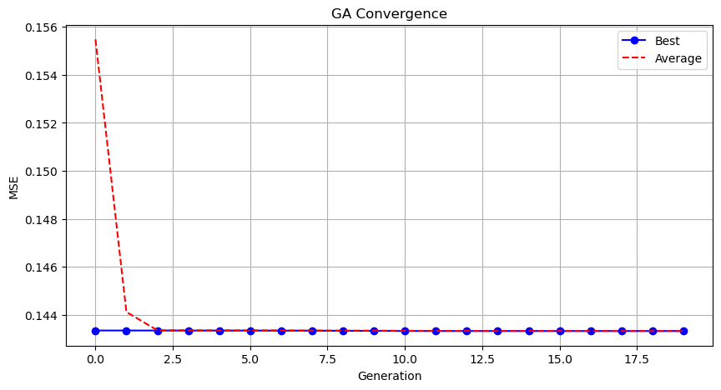

Genetic Algorithm completed successfully with MSE: 0.1433

==================================================

Running Particle Swarm Optimization...

==================================================

==================================================

=== PARTICLE SWARM OPTIMIZATION ===

==================================================

[Initialization]

- Swarm size: 30 particles

- Iterations: 20

- Cognitive weight: 0.5

- Social weight: 0.5

- Inertia weight: 0.5

- Search space: 50 features

- Target: Minimize MSE using XGBoost

==================================================

=== OPTIMIZATION RESULTS ===

==================================================

▶ Best MSE achieved: 0.143342

▶ Time elapsed: 22.20 seconds

▶ Features selected: 27/50 (46.0% reduction)

▶ Selected features (with weights):

1. CreditScore (weight: 1.000)

2. AnnualIncome (weight: 0.757)

3. Age (weight: 0.584)

4. EmploymentStatus (weight: 1.000)

5. MaritalStatus (weight: 0.683)

6. EducationLevel (weight: 0.805)

7. NumberOfOpenCreditLines (weight: 0.836)

8. NumberOfCreditInquiries (weight: 1.000)

9. DebtToIncomeRatio (weight: 1.000)

10. BankruptcyHistory (weight: 0.636)

11. LoanPurpose (weight: 1.000)

12. InterestRate (weight: 0.854)

13. SavingsAccountBalance (weight: 0.858)

14. CheckingAccountBalance (weight: 0.504)

15. InvestmentAccountBalance (weight: 1.000)

16. RetirementAccountBalance (weight: 1.000)

17. TotalAssets (weight: 0.634)

18. RentPayments (weight: 0.728)

19. StudentLoanBalance (weight: 0.745)

20. LifeInsuranceStatus (weight: 1.000)

21. HomeInsuranceStatus (weight: 0.526)

22. OtherInsurancePolicies (weight: 1.000)

23. JobTenure (weight: 0.555)

24. AnnualBonuses (weight: 0.536)

25. MonthlyTransportationCosts (weight: 0.614)

26. MonthlyHealthcareCosts (weight: 0.640)

27. MonthlyEntertainmentCosts (weight: 1.000)

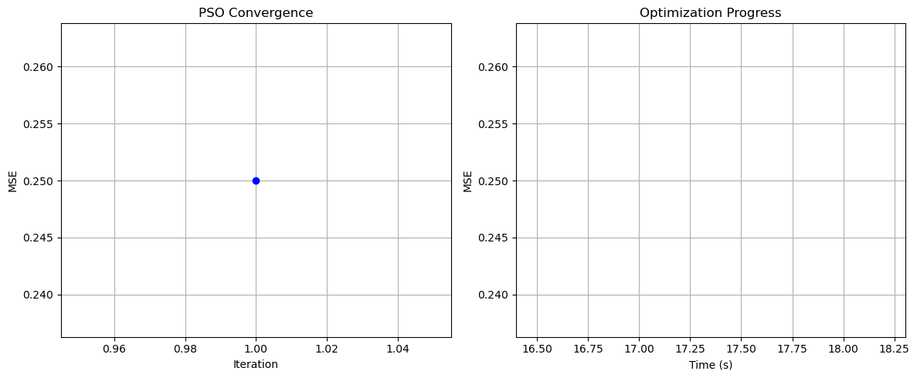

Particle Swarm Optimization completed successfully with MSE: 0.1433

==================================================

Running Whale Optimization...

==================================================

==================================================

=== WHALE OPTIMIZATION ALGORITHM ===

==================================================

[Initialization]

- Population: 30 whales

- Max iterations: 20

- Spiral coefficient (b): 1.0

- Search space: 50 features

- Target: Minimize MSE using XGBoost

[Optimization Progress]

Iter 20/20 | Best MSE: 0.143336

==================================================

=== OPTIMIZATION RESULTS ===

==================================================

▶ Best MSE achieved: 0.143336

▶ Time elapsed: 347.77 seconds

▶ Features selected: 20/50 (60.0% reduction)

▶ Selected features:

1. CreditScore

2. AnnualIncome

3. MaritalStatus

4. HomeOwnershipStatus

5. NumberOfOpenCreditLines

6. NumberOfCreditInquiries

7. LoanPurpose

8. PreviousLoanDefaults

9. PaymentHistory

10. SavingsAccountBalance

11. EmergencyFundBalance

12. TotalLiabilities

13. MortgageBalance

14. PersonalLoanBalance

15. CarInsuranceStatus

16. EmployerType

17. JobTenure

18. MonthlySavings

19. AnnualBonuses

20. MonthlyFoodCosts

▶ Convergence progress:

- Initial MSE: 0.1491

- Final MSE: 0.1433

- Improvement: 3.8%

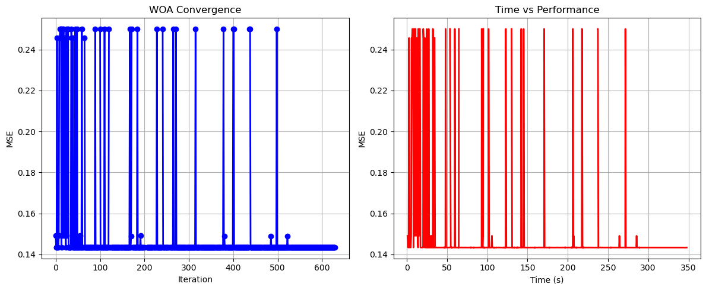

Whale Optimization completed successfully with MSE: 0.1433

==================================================

Running Squid Game Optimizer...

==================================================

==================================================

=== SQUID GAME OPTIMIZER (SGO) ===

==================================================

[Initialization]

- Players: 30 (15 offensive, 15 defensive)

- Max games: 20

- Search space: 50 features

- Target: Minimize MSE using XGBoost

==================================================

=== OPTIMIZATION RESULTS ===

==================================================

▶ Best MSE achieved: 0.143320

▶ Time elapsed: 359.33 seconds

▶ Features selected: 19/50 (62.0% reduction)

▶ Selected features:

1. CreditScore

2. AnnualIncome

3. LoanDuration

4. Age

5. HomeOwnershipStatus

6. NumberOfOpenCreditLines

7. DebtToIncomeRatio

8. BankruptcyHistory

9. LoanPurpose

10. InterestRate

11. CheckingAccountBalance

12. RetirementAccountBalance

13. StudentLoanBalance

14. HealthInsuranceStatus

15. CarInsuranceStatus

16. OtherInsurancePolicies

17. MonthlyHousingCosts

18. MonthlyFoodCosts

19. MonthlyHealthcareCosts

▶ Convergence progress:

- Initial MSE: 0.1433

- Final MSE: 0.1433

- Improvement: 0.0%

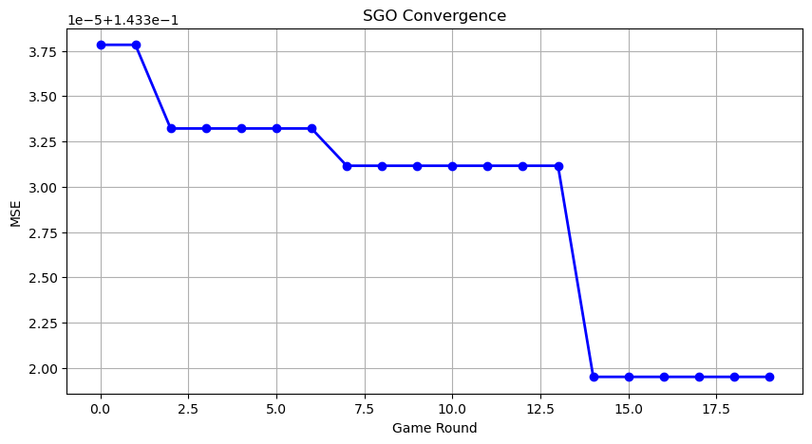

Squid Game Optimizer completed successfully with MSE: 0.1433

==================================================

Running PSH-Hyptrite...

==================================================

==================================================

=== PSH-HYPTRITE OPTIMIZATION ===

==================================================

[Initialization]

- Search points: 30

- Max iterations: 20

- Initial radius: 0.5 (adaptive)

- Hypersphere samples: 3 per point

- Search space: 50 features

- Target: Minimize MSE using XGBoost

[Optimization Progress]

Iter 20/20 | Best MSE: 0.143329 | Radius: 0.0250

==================================================

=== OPTIMIZATION RESULTS ===

==================================================

▶ Best MSE achieved: 0.143329

▶ Time elapsed: 1222.86 seconds

▶ Features selected: 26/50 (48.0% reduction)

▶ Selected features (with weights):

1. CreditScore (weight: 0.509)

2. AnnualIncome (weight: 0.732)

3. Age (weight: 1.000)

4. EmploymentStatus (weight: 0.885)

5. EducationLevel (weight: 0.512)

6. HomeOwnershipStatus (weight: 0.802)

7. MonthlyDebtPayments (weight: 0.532)

8. BankruptcyHistory (weight: 0.611)

9. PreviousLoanDefaults (weight: 0.805)

10. InterestRate (weight: 0.575)

11. PaymentHistory (weight: 0.803)

12. CheckingAccountBalance (weight: 0.535)

13. RetirementAccountBalance (weight: 0.623)

14. EmergencyFundBalance (weight: 0.871)

15. TotalAssets (weight: 0.506)

16. NetWorth (weight: 0.757)

17. MortgageBalance (weight: 0.955)

18. StudentLoanBalance (weight: 0.640)

19. UtilityBillsPaymentHistory (weight: 0.580)

20. HealthInsuranceStatus (weight: 0.750)

21. LifeInsuranceStatus (weight: 0.691)

22. CarInsuranceStatus (weight: 1.000)

23. HomeInsuranceStatus (weight: 0.897)

24. MonthlyHousingCosts (weight: 0.917)

25. MonthlyFoodCosts (weight: 0.609)

26. MonthlyHealthcareCosts (weight: 0.722)

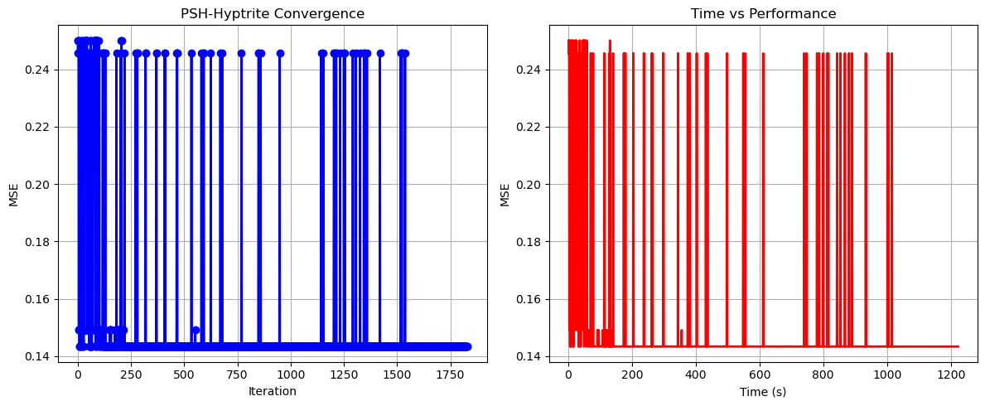

PSH-Hyptrite completed successfully with MSE: 0.1433

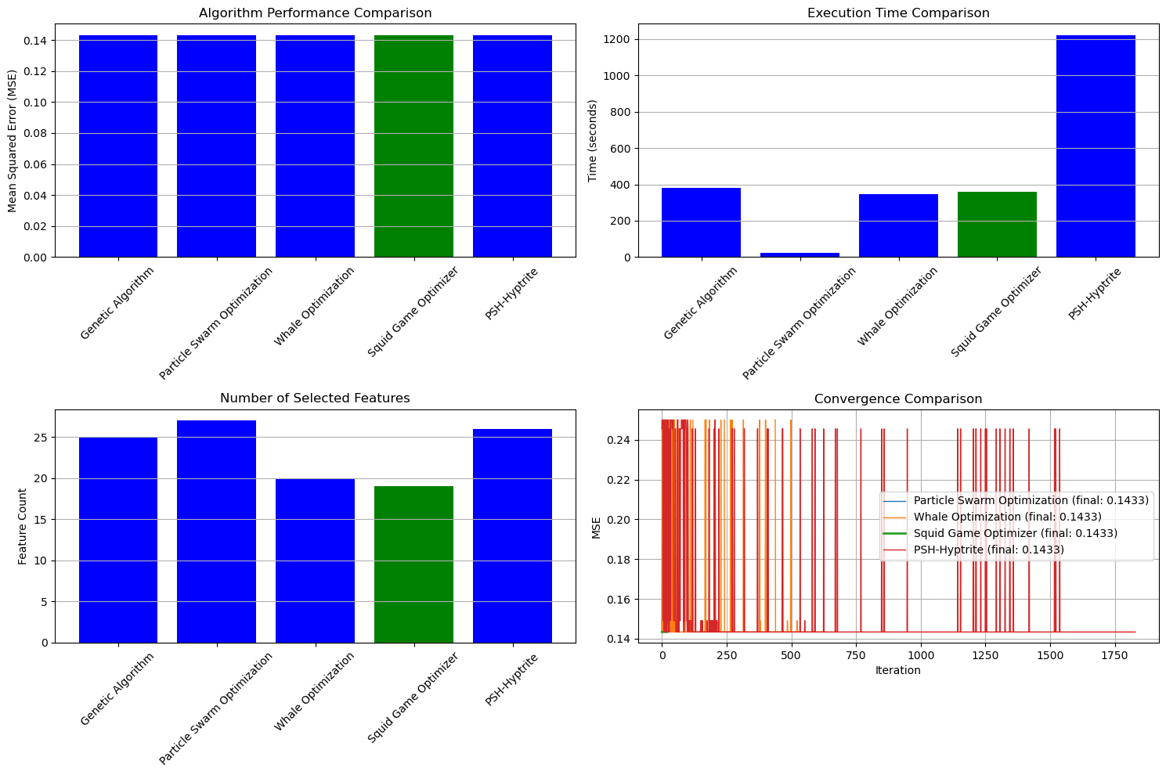

==================================================

FINAL RESULTS SUMMARY

==================================================

🏆 Best Algorithm: Squid Game Optimizer

📉 Best MSE Achieved: 0.143320

⏱️ Execution Time: 359.33 seconds

🔢 Features Selected: 19

Selected Features:

1. CreditScore

2. AnnualIncome

3. LoanDuration

4. Age

5. HomeOwnershipStatus

6. NumberOfOpenCreditLines

7. DebtToIncomeRatio

8. BankruptcyHistory

9. LoanPurpose

10. InterestRate

11. CheckingAccountBalance

12. RetirementAccountBalance

13. StudentLoanBalance

14. HealthInsuranceStatus

15. CarInsuranceStatus

16. OtherInsurancePolicies

17. MonthlyHousingCosts

18. MonthlyFoodCosts

19. MonthlyHealthcareCosts